Installing Kubernetes on ubuntu

When installing Kubernetes on ubuntu I switched into the root user by using **su – root.** Then I was used **curl -s https://packages.cloud.google.com/apt/doc/apt-key.gpg | sudo apt-key add** to add a Kubernetes key. Next, I used **sudo apt-add-repository "deb http://apt.kubernetes.io/ kubernetes-xenial main"** to add the repositories for Kubernetes. After that was added I used **sudo apt-get install kubeadm kubelet kubectl** to install the Kubernetes tools. Lastly I checked the version of the Kubernetes tool by using **kubeadm version.**

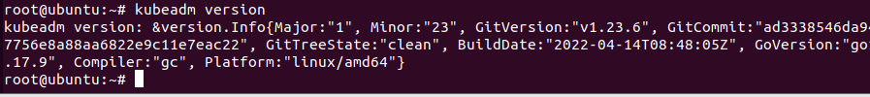

Installing Kubernetes on CentOS

When installing Kubernetes on CentOS it was a little different from the ubuntu server. The first thing I did was make I was in the root user. Next, I used **cat <<EOF > /etc/yum.repos.d/kubernetes.repo** To retrieve the Kubernetes repositories. After I hit enter type on the “>” type

> [kubernetes]

>name=Kubernetes

>baseurl=https://packages.cloud.google.com/yum/repos/kubernetes-el7-x86_64

>enabled=1

>gpgcheck=1

>repo_gpgcheck=1

>gpgkey=https://packages.cloud.google.com/yum/doc/yum-key.gpg https://packages.cloud.google.com/yum/doc/rpm-package-key.gpg

>EOF

Next, I use **sudo yum install -y kubelet kubeadm kubect1**  to install Kubernetes, after Kubernetes was installed I had to enables it by using **systemctl enable kubelet** then I proceeded with **systemctl start kubelet** with this command I enabled it and also started it. I can also check the status of the kubelet by using  **systemctl status kubelet.**

Wok cited

<https://phoenixnap.com/kb/install-kubernetes-on-ubuntu>

<https://phoenixnap.com/kb/how-to-install-kubernetes-on-centos>